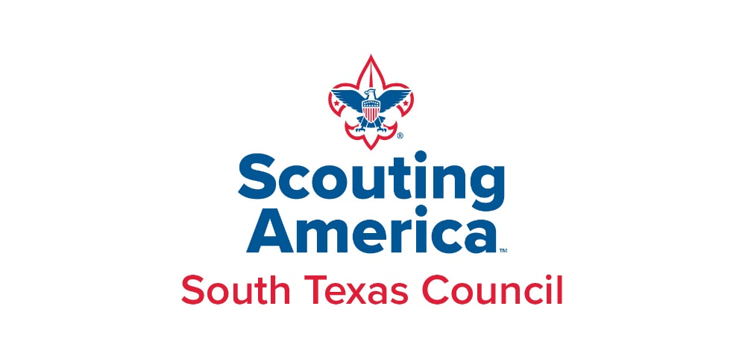

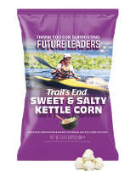



2024 POPCORN SALE

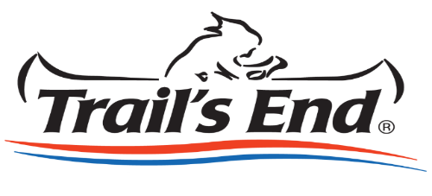

SUPPORT CONTACT INFORMATION
District Popcorn Kernels Support You!
Contact your District Kernel for Information

 | DISTRICT KERNALS/SUPPORT | PHONE | EMAIL
Aztec | Eliza Elizalde | 956.285.0766 | emtzelizalde@yahoo.com
LaSalle | Francisco Orozco | 361.816.3868 | Francisco.Orozco@scouting.org
Phoenix | James Rangel | 361.816.3843 | James.Rangel@scouting.org
Sea Breeze | Mikell West | 361.215.8487 | mikellwest@gmail.com
Venado | James Rangel | 361.816.3843 | James.Rangel@scouting.org

Council Popcorn Staff Support

James Rangel
361-816-3843
James.Rangel@Scouting.org

POPCORN SALE CALENDAR
AUGUST  Popcorn Kick offs and Training 8/6-8/10  Take Order/Online Sale Begins 8/6  Show & Sell Popcorn Orders Due Online 8/22  Unit Popcorn Kickoff Events – Scheduled by Units  SEPTEMBER  Show & Sell Order Pick- up (by district) 9/5-9/7  Show and sell, online and take order sale | OCTOBER  Show & Sell Payment Due 10/15  Take Order Popcorn Due Online 10/24  NOVEMBER  Take Order Popcorn Pick up(by district) 11/7-11/9  Take Order Popcorn Payment Due 11/22  DECEMBER  Prize orders deadline 12/31

POPCORN PICKUP
SHOW & SELL PICKUPS  Sept 6-10  Date, Time, Location by District | SHOW & SELL PAYMENTS  Oct 15th  NO RETURNS | TAKE ORDER PICKUPS  Nov 7-9  Date, Time, Location by District | TAKE ORDER PAYMENTS  Nov 22nd  NO RETURNS

Be sure to bring a large enough vehicle to haul your order: 20 cases Mid-Size Car
40 cases Mid-Size SUV
60 cases Minivan
70 cases Large SUV

Unit Popcorn Kernel Role
Helping Your Unit Succeed

1ST LINE OF SUPPORT: District Popcorn Kernel/District Executive

PROFESSIONAL SUPPORT: District Executive & Council’s Popcorn Specialist

YOUR COMMITMENT: Organize and manage your unit’s popcorn sale to meet or exceed your goal.

MEETINGS/EVENTS: District Roundtables (Suggested - meet with other Kernels and share ideas)
Popcorn Sales Training and New Trails End App Training! Trails end Webinars at https://www.youtube.com/@trailsendpopcorn203
Council-wide Popcorn Kickoff (Suggested)
Unit Popcorn Kickoff, Committee, Unit Meetings as scheduled

KEYS TO SUCCESS:

- Have a unit popcorn planning meeting.
- Attend a scheduled South Texas Council Kickoff Held in early August.
- Develop your unit’s Ideal Year of Scouting and how much it’s going to cost. Decide on a unit sales goal and then divide that goal into a “per scout” goal.
- Sign up your unit on the Trails End Unit Commitment Tracker by August 1st and forms available online at http://southtexasbsa.org/popcorn/.
- Use Show & Sell Suggested Order Calculator and place your unit order by August 22nd by 5pm.
- Develop a unit Popcorn Committee to help you ensure an effective and efficient selling program.
- Develop an incentive plan for your Scouts in addition to the Council prize program
- Host a FUN & EXCITING Unit Kickoff Event.
- Pick-up your unit’s show & sell and take order popcorn on the assigned date and be sure to bring a vehicle(s) large enough to accommodate your popcorn order. Make sure to allow enough time to verify product counts and sign the Unit Packing Slip form acknowledging receipt.
Pay your unit’s balance due minus credit received and outstanding commission for each sale with one check or money order to receive maximum profit for your Scouts.

GETTING STARTED

Congratulations and thank you for signing up to be your Unit’s 2024 Popcorn Kernel. As you already know, a well implemented popcorn season can fund a Unit’s program for the entire year. Studies have shown that Unit’s with a clear Unit goal, individual Scout goal, energetic kick-off and caring volunteers like you will exceed their Unit goals. Don’t worry, you have a Council and District team to help you along the way. Here is what to do next….

Get on the STC info distribution list – Fill out Unit Commitment form and send to James.Rangel@scouting.org to sign up as the Unit Popcorn Kernel. Provide your Unit type, Unit number, personal phone and mailing address. Don't miss any important communications
Access to Trails End Popcorn System- Once you have signed up and turned in your information sheet, you will need to register your unit online. PowerPoint Presentation (southtexasbsa.org) Link to sitehttps://www.trails-end.com/unit-registration
Get into Trail's End Online Ordering (Scouts must sign up individually for online sales)- Got to http://sell.trails-end.com/ Select Online Sales in the middle left of the page, Select Create an Account at top right of page, Select Leader from the drop-down list and complete.
Enter all Scouts info in the system and link them to your unit account. Any scout selling, scout, leader must download the app to track sales.
Unit Goal- Meet with your Unit's Committee to determine how much money is needed for an ideal year of Scouting. Need help with building a budget, us the Ideal Year of Scouting form and talk with you District Executive

2024 PRODUCT LINE

Below are the items that will be available for this fall.

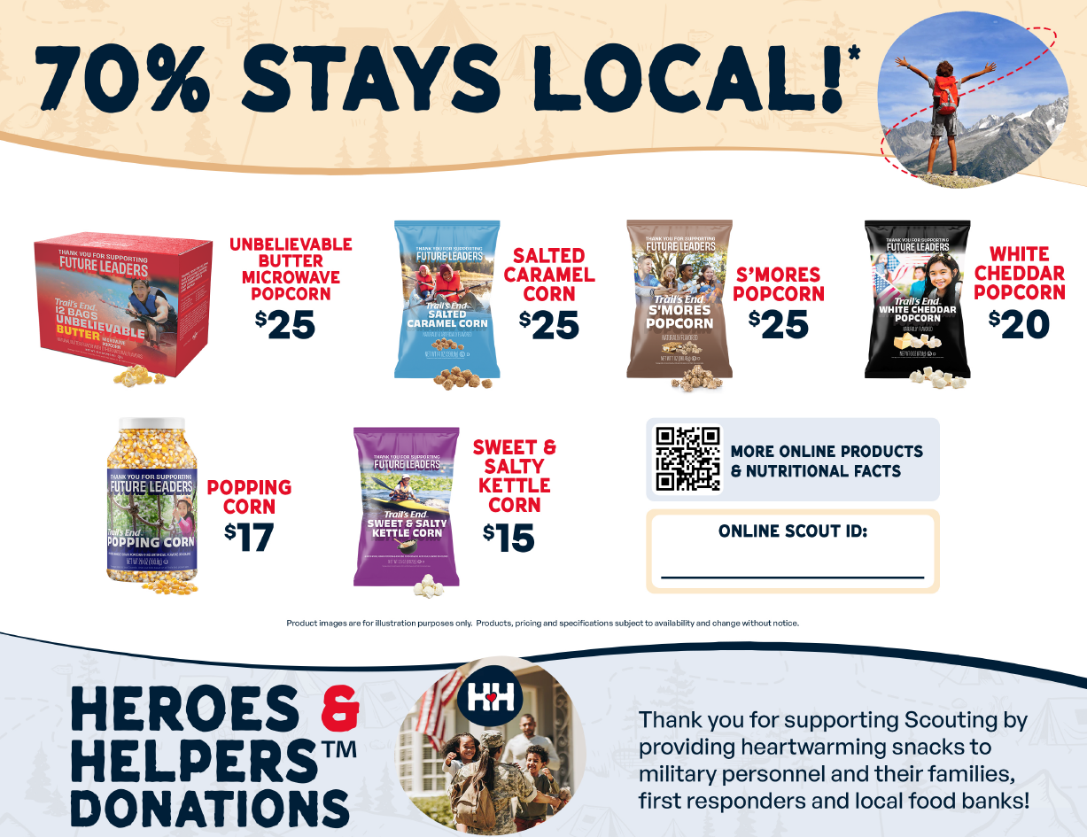

CUSTOMER RECEIPTS
Each year the Council receives several phone calls from people who ordered popcorn from a Scout, paid for it, and never received it. The Council recommends that you do not collect any money until you deliver the product. If you do collect money up front, give the customer a receipt (samples are provided online) with contact information and the date of when to expect delivery of their order. This will help ensure the people supporting Scouting through the popcorn sale will receive their popcorn and continue to purchase for years to come

2024 UNIT COMMISSION & PRIZE PROGRAMS

Commission Structure

All Units Receive base 30% Commission of Gross Sales.

To earn maximum profit from the sale it is recommended the unit:

Attends the August Council Kickoff
Host a unit kickoff – provide date for kickoff
Pay Show and Sell order by October 15th with one check,
Pay Take Order by November 22nd with one check.
Place Show & Sell and Take Order Popcorn Orders utilizing Trails End Popcorn System

With the new App, the unit balance will be paid according to sales and be credited to unit balance weekly. If the unit has a commission and balance paid off, it will be credited and can be paid out weekly!

Additional Bonus Commission Levels:

- Level 1 Participate in all 3 sales-Take Order, Show and Sell and Online Extra 6%!
- Level 2 Participate in all 3 sales and Sell $5,000 or more and receive an additional 7%!
- Level 3 Participate in all 3 sales and Sell $10,000 or more and receive an additional 8%!
- Above are for total gross sales including Take order and Show and Sale only.
- Opt out of Prizes for an additional 2%

2024 Prize Program

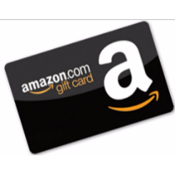Trail’s End
Scout Rewards

Amazon.com Gift Card rewards managed
and digitally redeemed by Scout through Trail’s End.

Benefits for Scouts:
- Can choose the prize THEY want on Amazon.
  - No preset prize selection
    - Sellers aged 5 to 18, male and female
  - Over 70% of households are Amazon Prime (free shipping).
- Receive more reward value at every level.
- Uncapped levels to incentivize top sellers to keep selling.
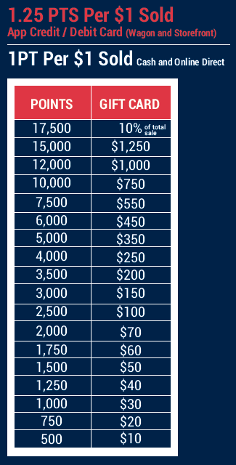

COUNCIL-SPECIFIC BONUS PRIZES
A Scout is Trustworthy - Please respect the spirit of the contests. No combining of orders.
- Top Seller in Council -Top seller in District
- Top Selling unit in Council and in each district
- Scout $2000 high Sellers Club Party


MILITARY DONATIONS
2024 kicks off the 18th year of Trail’s End Popcorn for our Troops program.

- Consumers have donated over $47 million worth of popcorn to U.S. troops
- In 2015 alone, consumers purchased over 145,000 donations
- Over 4,300 tons of popcorn treats have been shipped to hundreds of locations around the world
- Consumers have placed over 120,000 orders online for the Military Product Donation
Trail's End ships popcorn to veterans' organizations, U.S. troops stationed in Afghanistan and Iraq, all other U.S. Military Bases overseas, domestic U.S. Military Bases, and families of U.S. servicemen and women.

Be sure to promote POPCORN FOR OUR TROOPS, because the unit commission on Military Donations is the same as any other product sold. Therefore, the unit earns the same commission, but does not receive or deliver any popcorn product.

CASH DONATIONS
Per BSA Policy on Fundraising, units may not solicit cash donations for general use. However, while selling popcorn, cash donations are often received. Turn in donated cash in the form of Military Donation orders - - - for every $25 received, report 1 $25 Military Donation.

WANT TO INCREASE YOUR INCOME & SUPPORT OUR TROOPS??? Put out a donation canister to collect change from purchases, loose change, and money from those not interested in buying popcorn. Most people will give to our soldiers even if they can’t buy popcorn.

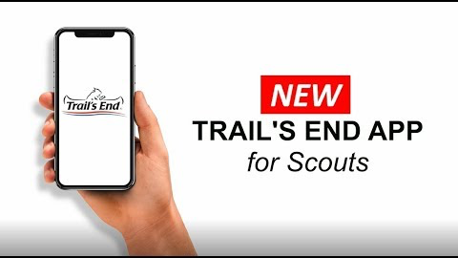
ALL SALES MUST BE TRACKED USING NEW TRAILS END APP!
Mobile app for Scouts to track and report real-time storefront, wagon, and online sales, accept cash and credit cards, track inventory by Scout and storefront,
and schedule Scouts for storefronts.
2018 Proven Test Results: 191 units / 2,300+ Scouts sold $1.9 million and grew 26%.
Benefits for units:
- NO CREDIT CARD FEES (paid by TE) – powered by Square.
- Compatible with your Square readers.
- Automatically communicates and tracks sales for Scout Rewards.
Benefits for Scouts:
- Every Scout can do credit card sales (20% higher vs cash).

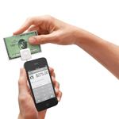
CREDIT CARD PAYMENTS
Tired of losing sales to “Sorry, I don’t have any cash?”

New trails end app utilizes and is powered by square! NO FEES to the unit!

POPCORN SELLING OPTIONS
Use more than one method to increase funding for your Scouting Adventures!

- Take Order - A scout goes door to door with a take order form with a parent or a buddy, the customer writes their order on the form, the scout returns to deliver the product and collect payment in a few weeks. Increase future selling potential by including a hand-written thank-you note with each customer’s order

Advantage: Higher dollar sales per customer. Order now, come back to deliver product and take payment!

- Show and Sell - The unit works as a team at a location(s) to show their products and to make immediate sales after getting permission to sell in front of a business, storefront, or other location. Locations can be reserved through your District Popcorn Kernel. In order to reduce burden upon our business partners, please do not contact business without coordinating with your District Popcorn Kernel.

Advantage: Access to different customers to make extra sales! This is an opportunity for every Scout to become more at ease with interacting with customers. Sales count towards the unit sale even if he opts not to participate in take order.

- Show and Deliver – Same process as take-order but you use your show-and-sell stock.

Advantage: Can give the product right to the customer and take payment! No coming back to the customer later. However, you will have a more limited product selection.

- Online - Allows Scouts to sell online to family and friends through https://www.trails-end.com/Support/Scout

Advantage: Sell to customers all year, get credit, accept credit cards, and no delivery or collection from customers! Reach customers all over. Online sales count toward Council rewards during the annual fall popcorn sales.

SELLING POPCORN ONLINE-

Sell popcorn to friends and family online.
There is an online account available for each individual unit and/or for each individual Scout. Sales generated online qualify toward Scout Rewards and scholarship credit. Your Unit will receive 30% commission on these sales which will be credited to your unit account each quarter. For information on setting up the Scouts in the system and for how the Scouts can set up their own sales pages please go to http://sell.trails-end.com/.
$12-$13 Flat shipping until $65 reached
$65+ Free Shipping

INVENTORY, RETURNS & PAYMENT
Product Inventory
All popcorn ordered from Trail’s End cannot be returned so becomes the property of the South Texas Council. Some returned popcorn is used to fill Take Orders and as thank you gifts and promotions, but a large quantity goes to waste each year. This represents money that cannot be reinvested in the Scouting program. Order your popcorn based on last year’s sale and changes on your unit membership and using the Show & Sell Suggested Order Calculator.
- Look at your sales plan. Do you have more or less sale sites lined up than you had last year?
- When you set sales goals for each family, do not give them all of the popcorn needed to reach the goal at the start of the sale. Give them about 70% of the product needed.
- Have a pickup/return and money turn in day to help you see who is selling and redistribute the popcorn to the families who are selling.
- Ask the Scout families not to fill their family’s orders first, but to do so at the end of the sale. This will provide for storefront and neighborhood sales. The family orders can be filled with popcorn from returns from other Scouts or the take order.
- Additional popcorn will generally be available for check-out throughout the course of the sale.

COUNCIL’S RETURN POLICY & PROCEDURES
NO RETURNS WILL BE ACCEPTED
- If you have remaining product, contact your District Popcorn Kernel for possible transfers.
- We will write up your order and you will sign for it. Keep a copy for your records.

COUNCIL’S PAYMENT POLICY & PROCEDURES

Full payment, minus the unit’s earned commission and balance, is due by Tuesday, October 15th for Show and Sale and Friday November 22nd, 2024 for take order. Unit with any balance should submit ONE check payable to the South Texas Council

STEPS FOR A SUCCESSFUL UNIT SALE

Units having the greatest success in the popcorn sale have several things in common…
- Attend Popcorn Training to learn and pick up all your sales materials.

- LEAD with Enthusiasm - This is a motivating factor for both the Scouts and their parents.

- COMMUNICATE Effectively - Make sure Scouts and parents understand the popcorn sale plan.

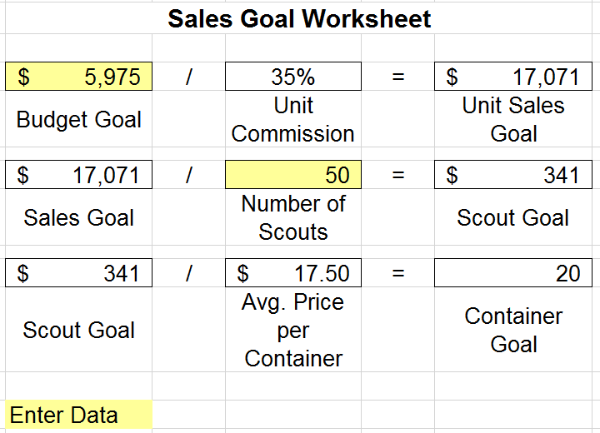
- Include Popcorn in your Unit Budgeting - Planning the unit’s yearly program around a budget demonstrates just how much it costs to provide a great program.

- Establish GOALS - Both the unit and the Scouts need goals. The unit can plan the annual program around the sale. A great sale helps enable a great program. Planning and explaining the benefits of the Scouts’ goals motivates both the youth and his parents.

- EDUCATE parents of the direct benefits to them - i.e. Johnny sells $x amount in popcorn and gets to go to camp…...without Mom or Dad having to open their checkbook.

- EXPLAIN benefits of this important fundraiser, including Scholarship Program, prizes, free program activities, opportunity for scouts to build confidence and learn salesmanship techniques, and how this fundraiser gives back to the unit and the council.

- HOST a FUN and EXCITING unit KICKOFF to provide families with all the materials and MOTIVATION for a successful sale. Review prizes and incentives.
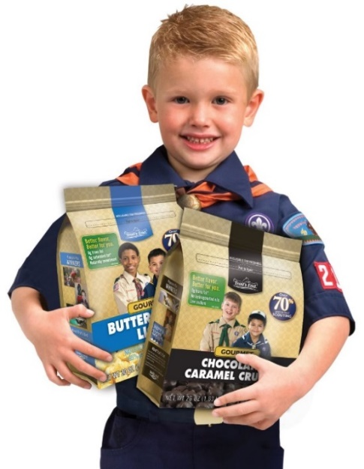
- CREATE a UNIT INCENTIVE PROGRAM in addition to the Council Rewards Program. For example each Scout who sells $500 gets to go to Day Camp for free, or a portion of Webelos Camp or Summer Camp is paid; top selling den / patrol gets a pizza party; sell $800 or more and the Scout gets to pie the Cubmaster / Scoutmaster; Scout that has the highest sales each week gets a prize.

- ESTABLISH a Customer Base - Make 2 copies of all Take Order forms: one for the Scout to use to distribute orders and one to keep with Unit Records to call on the customer next year.

- Keep accurate records - Collect the money when popcorn is delivered. Schedule a turn-in party at the end of the sale to collect orders and money from the Scouts.

- Remind parents of all the great uses popcorn gifts make for teachers, co-workers, neighbors, babysitters, friends, and relatives.

UNIT POPCORN KICKOFF SUGGESTIONS

A successful popcorn kickoff is the single most important part of your popcorn sale!

Here is a kickoff plan to get you started. Customize your kickoff to suit your unit. A sample Power Point Presentation is available on at http://sell.trails-end.com/

Objective: Get scouts excited about what they can win. Get parents informed about why they should sell.
Keep it fun! Keep it moving! Keep it short!
Preparation: Have a display and samples available. Link into the theme of 2024 Amazon prize program. Have a laptop and/or projector to show portions of the Trail's End PowerPoint found on Trails-end.com (Leaders Section). List on a poster or board how the funds raised through the popcorn sale will be used to enhance the unit program. Have a chart with each scout's name and the unit popcorn sales goal. Keep the gathering upbeat, fun, and informative!
Suggested Agenda:
- Opening: Serve some samples, give away some prizes, play a “popcorn” related game, or get ideas from http://sell.trails-end.com.

- Review your unit's “Ideal Year of Scouting:” Explain the activities, the costs, and how they relate to the Per Scout Sales Goal.

- Explain the Key Dates: Review the sale period, show, and sell events and sign-ups, weekly reporting, and money collection. Cover any special incentives your unit might be using. Provide a popcorn sale fact sheet that includes key dates and locations for the sale.

- Scout Training: Practice door-to-door approaches and review proper manners in talking to adults. Make sure each scout knows his goal.

- Prizes or Incentive Plan: Review the Council’s prize program, bonus prizes, and weekly drawings. If using some other incentive plan that best meets your needs, cover how that will work. Units not participating in the Council’s prize program are still eligible for bonus prizes and participate in the weekly drawing.

- The Big Finish: The year's top sellers might throw cream pies at their leaders, shave the Cub/ Scoutmaster's head or some other fun, non-destructive exciting experience. Send the Scouts home eager to be successful!

- Thank the Scouts and Families for helping to make the unit a success. But most importantly remind them to HAVE FUN and be successful so that everyone will have the best Scouting program year ever!

SELLING DO’S AND DON’TS

- DO: Wear your uniform. Everybody loves to support a Scout in uniform.
- DO: Sell in pairs or with a parent. Per BSA’s Youth Protection Policies, be sure to maintain TWO-DEEP LEADERSHIP at all show and sell events and while walking door-to-door.
- DON’T: Sell after dark.
- DO: Act like a Scout - be polite and courteous, wear a smile and introduce yourself. You are the face of Scouting.
- DO: Tell your customers why you are selling popcorn and how the money will be used. Remember that you are asking for help supporting your Scout program, not “selling popcorn.”
- DO: Walk on the sidewalk and driveway, not through the yard. Watch for traffic.
- DON’T carry large amounts of cash with you.
- DON’T EVER enter anyone’s house.
- DO take 2 pens with you and make sure you keep your Take-Order form as neat as possible.
- DO know your product - all the different types of popcorn products you are selling…be prepared to answer, “Which is your favorite?”
- DO know the date when you will be delivering the popcorn to your customers?
- DO put popcorn sale articles in your school, place of worship, and community bulletins, and newsletters.
- DO remind your parents, grandparents, aunts, uncles and neighbors what a great gift Trail’s End Popcorn makes for teachers, friends, co-workers, etc. Also, let them know how quickly it runs out and buy enough from you to last them until next year.
- DO ask your friends at your place of worship if they would like to buy some Trail’s End popcorn.
- DO ask your parents if you can go to their office or club (Rotary, Kiwanis, Lions, bowling league, hockey league, etc.), to sell. Many business leaders give holiday gifts to clients and employees and Trail’s End popcorn makes a great gift.
- DO write a thank you note and place a copy of it on all the popcorn you sell. This will benefit you next year when you call on them. Inform people about https://www.trails-end.com/Support/Scout where they can buy popcorn year-round to support you and your Scouting unit.
- DO keep a copy of your Take Order forms so you can call on these people again next year. People will remember how polite and courteous you were, the nice thank you note they received, and the popcorn that they did not buy enough of!
- STATISTICS show 3 out of 5 houses buy Trail’s End Popcorn when asked. NOT every house will buy so do not become discouraged. THE MORE PEOPLE YOU ASK - THE MORE PEOPLE WILL BUY.
- DO SAY “THANK YOU” whether or not someone buys popcorn!

THE SALES PITCH
- Focus on Scouting instead of the product. ”Will you support Scouting by purchasing popcorn today?” “Will you help us go to camp by purchasing popcorn today?” Avoid asking if they would like to ‘buy popcorn’, if they just wanted to buy popcorn, they could get it cheaper in a store
- People buy popcorn to support Scouting and the Scout in front of them. They can’t buy the Scouting experience for a young person through store-bought popcorn.
- Be specific about how the money will be used. People are more willing to purchase if they know where the money is going. (70% of the money directly supports scouts in the South Texas Council to provide needed funds for camping, leadership development and staffing).
- Maintain eye contact. If the customer is not looking at you or you are not looking at them, somebody is not paying attention.
- Be polite. Use ‘Sir’ and ‘Ma’am’ when addressing potential donors.
- Don’t ask people IF they will buy – ask at which level they would like to support your Scout program with the various popcorn products and prices representing the various levels.
- Offer higher-priced products first to generate more program revenue.
- Dietary restrictions? –suggest Popcorn for The Troops donation or holiday gifts for teachers or coworkers
- Have the Scouts practice the pitch until they don’t have to think about what they are going to say.
- Most people do not buy because they were not asked…80%+ will buy popcorn when asked.
- Over 90% of people who buy popcorn from a Scout have made up their mind to support Scouting before they have even seen what the Scout is selling!
- Say THANK YOU – even if only for their time.
Note: Adults should be prepared to deal with people who espouse a political agenda. Our scouts don’t need to be exposed to this, so consider how to quietly defuse a situation. Do not get into an argument with the individual, simply affirm their right to hold an opinion and thank them for their thoughts.

Sample Sales Script

Hi, my name is (say first name only). I’m a Cub Scout with Pack ____.
We are raising money for our pack by selling popcorn. By buying popcorn today, you’ll be helping me earn my way to camp next summer and do fun things with my pack all year long. More than 70% of your purchase directly supports Scouting in the South Texas Council.
(Hand the customer the Take Order form and a pen, or at a Show and Sell, point out a high-cost product).
Which product would you like to buy, or would you rather send popcorn to our military?
You’ll help us, won’t you?
Thank you for your support in Scouting!
Notes

